**Bank App User’s guide**

**Target Users/Audience:**

* Regular Customers
* Bank employees

Following next, is the main Screen of the app, where the Users can click on “Manage Customers” button to be redirected to the next screen of the form.

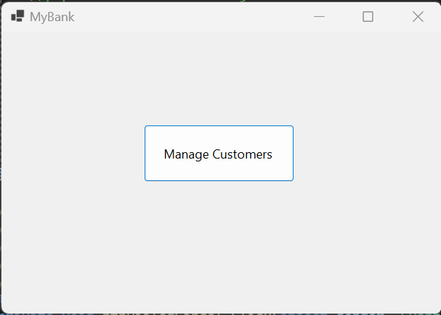

Once they click in the “Manage Customers” button it takes them to the “Customers Form”.

Here they can create the two different type of Customers the App is intended to, which are, *Staff* and *Normal* customers.

**Creating a Staff customer example:**

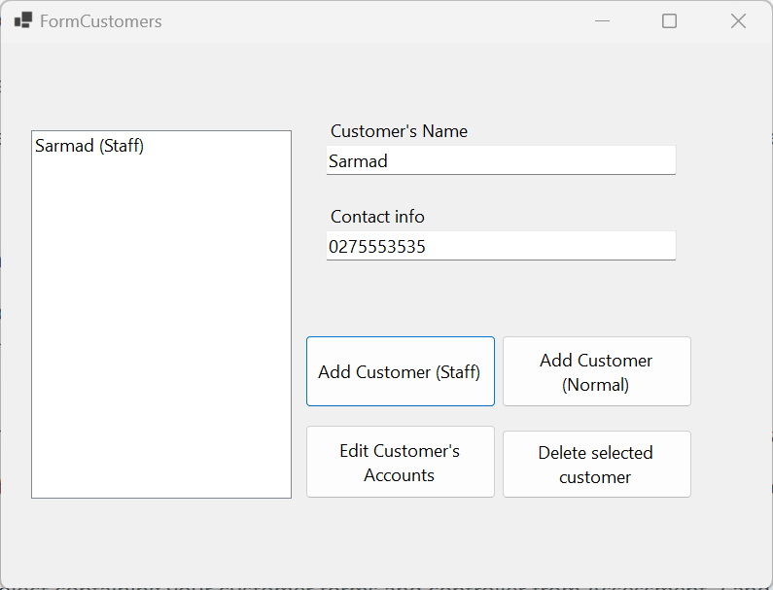

**Creating a Normal Customer example:**

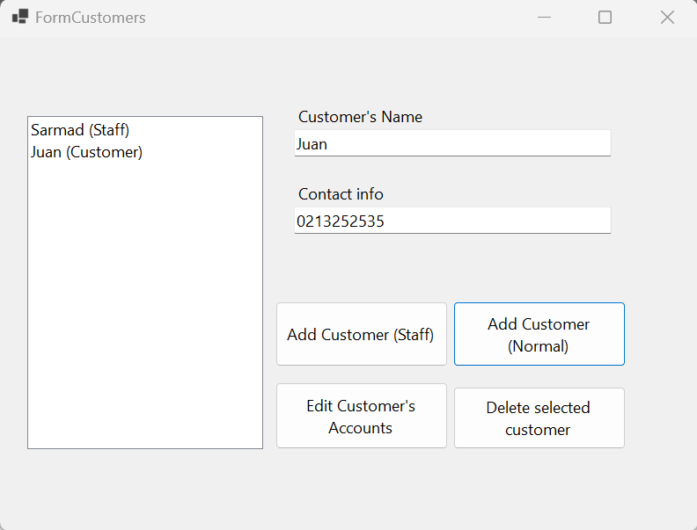

To Delete a Customer the user must select the Customer to be deleted first and then press the **“*Delete Selected Customer”*** button.

Example:

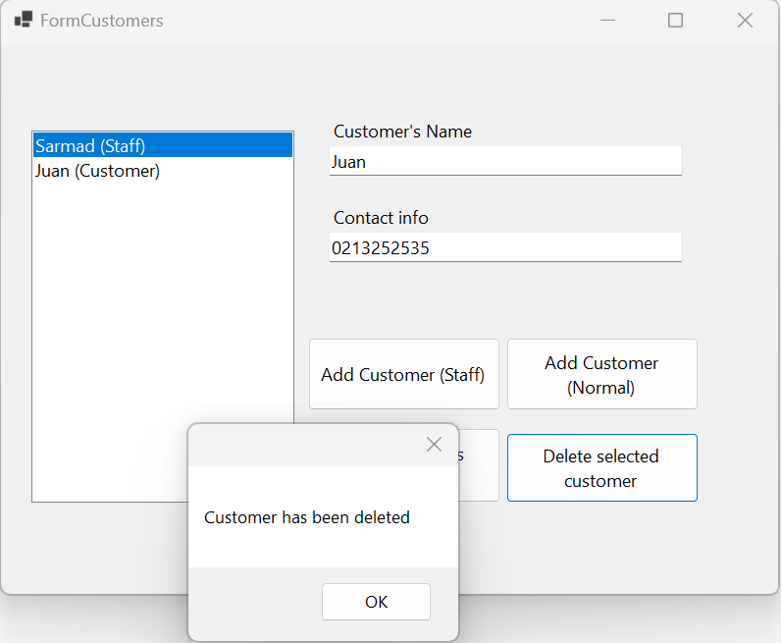

Once customers have been created, they can create the 3 different types of accounts, which are:

* EveryDay
* Investment
* Omni

To do so, the user has to positioned on his name and the click ***“Edit Customer’s Account”***.

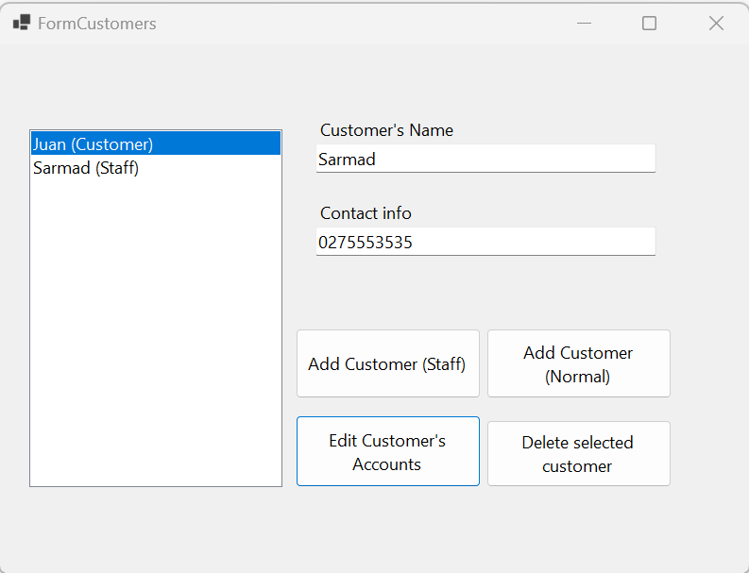

Once they do so, the Customer’s Account Form opens up:

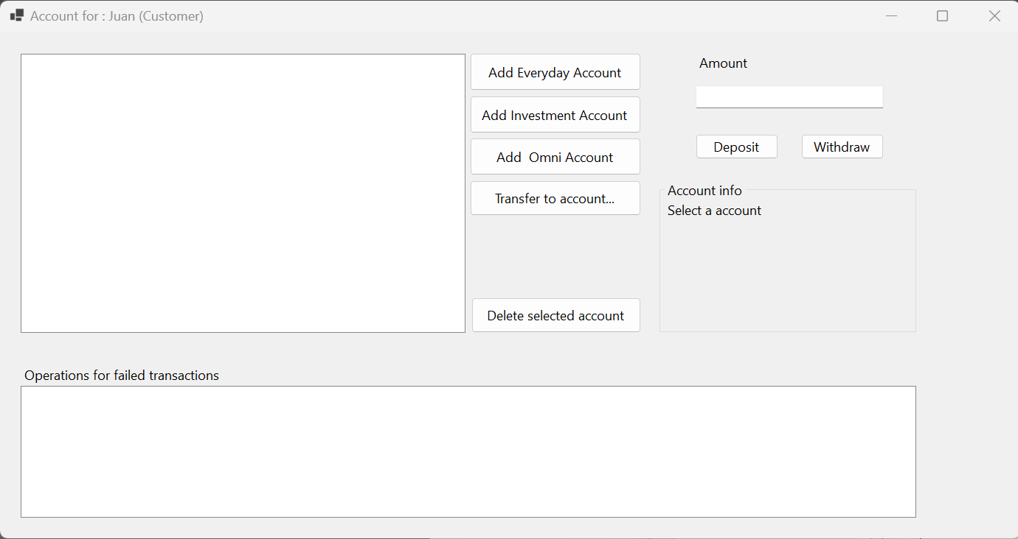

Here the User can start adding or creating the 3 different accounts, to later start making Deposits or Withdrawals.

To add an Account simply press on the “*Add Name of Account”* button and the account will be added to the box on the left showing the information belonging to that account:

Adding an Everyday account:

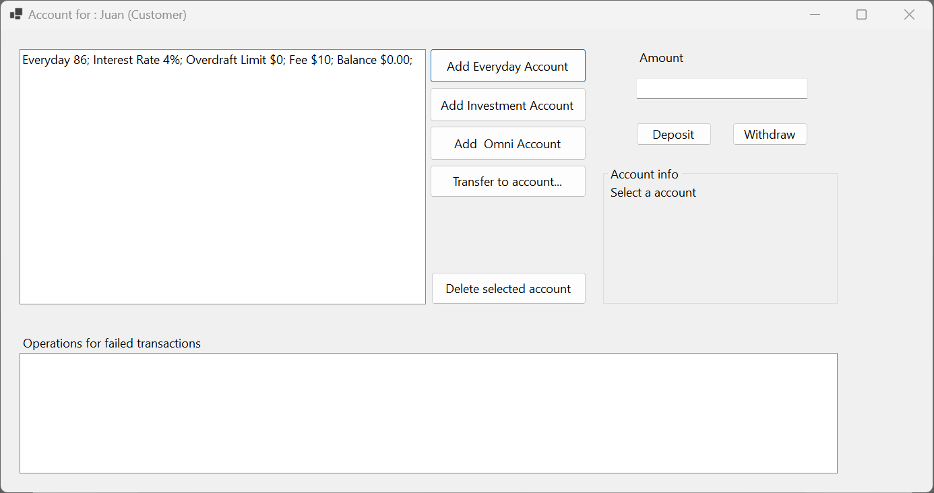

Adding an Investment account:

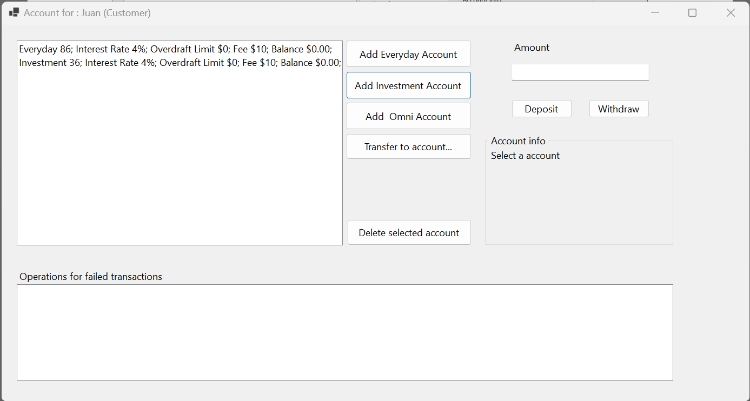

Adding an Omni account:

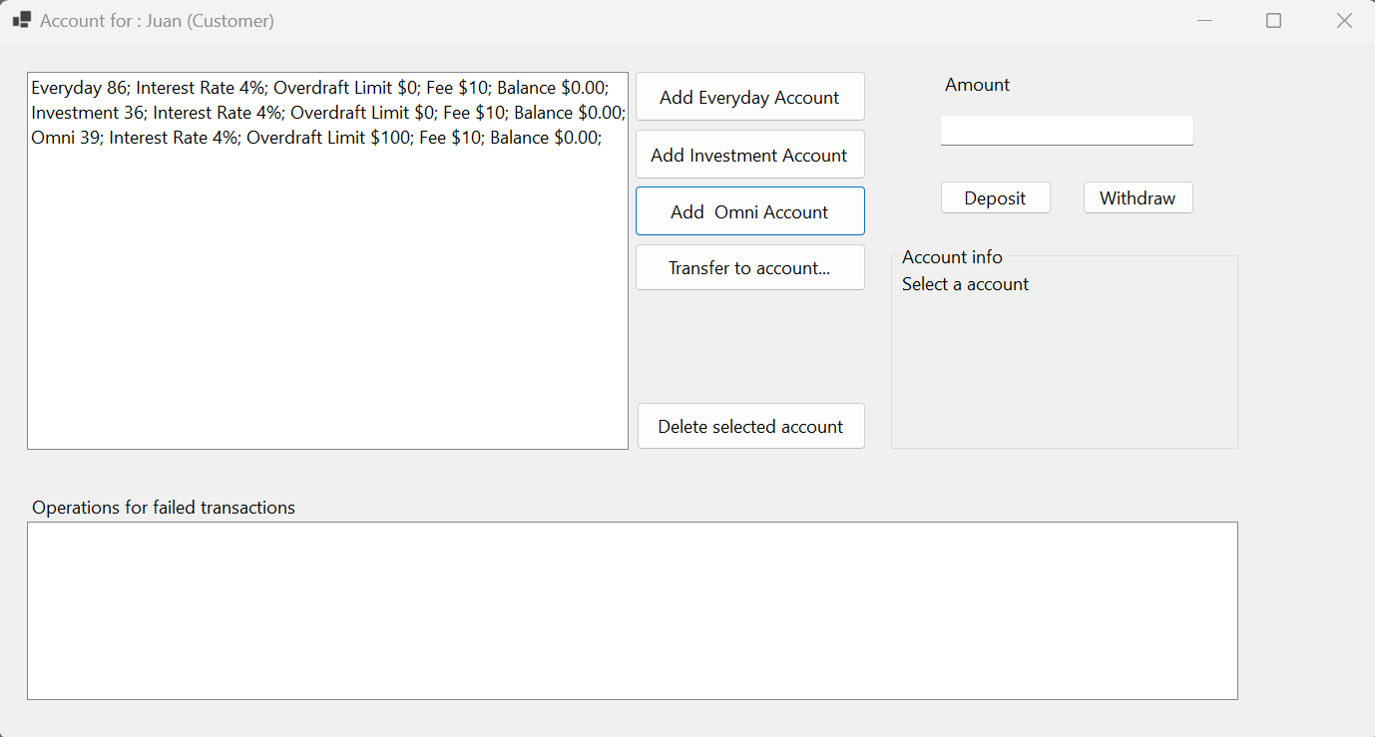

**Making a Deposit**

Then the next step would be depositing some amount in the created accounts.

To perform this, users have to introduce an amount in the ***“Amount*”** box located on the top-right part of the Customers account form and click on the ***“Deposit”*** button.

First select the account you want to Deposit:

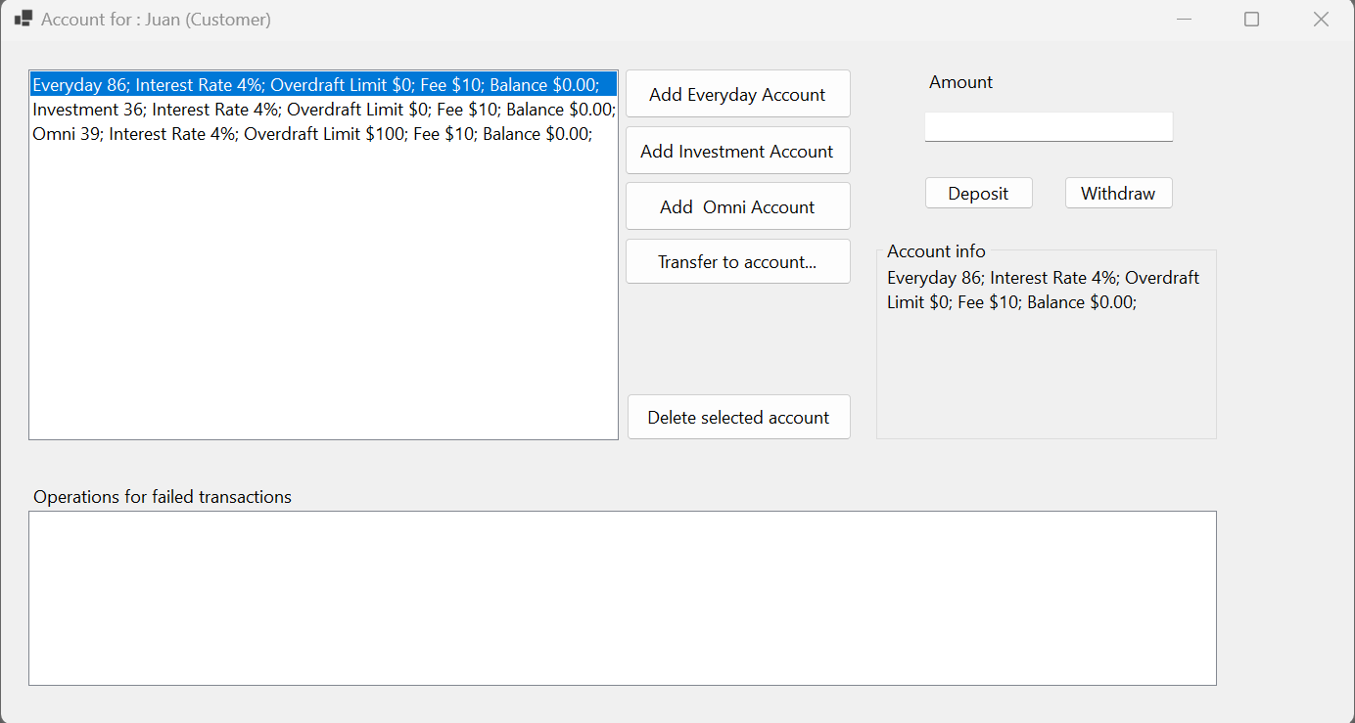

Then type the amount ad click on ***“Deposit”:***

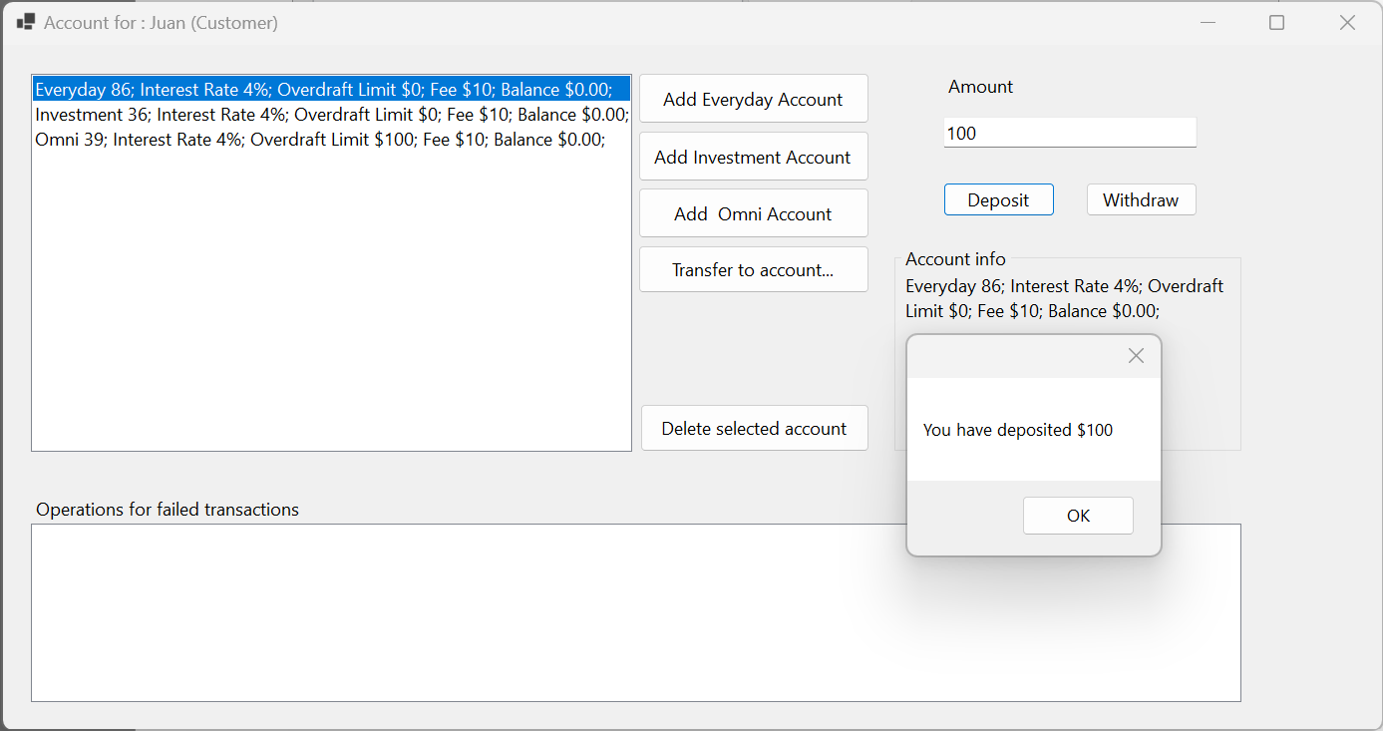

After clicking **“OK”** the user will be able to see the deposited amount of $100 in the Everyday Account:

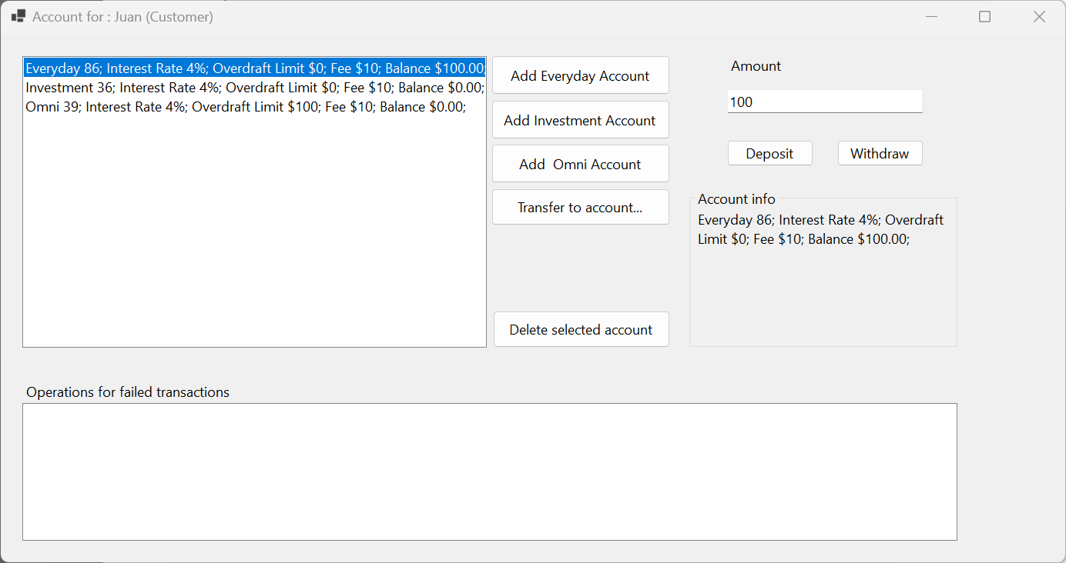

**Transferring money through accounts**

Now let’s transfer some money from the Everyday account to the Investment account and see the procedure.

In the previous step $100 were deposited. Now we will transfer $50 to the Investment account.

In order to do so, the user has to follow the next steps:

1. Click on the “Transfer to account” button.
2. In the new pop-up window, select in the Dropdown the account the amount that will be transferred from.
3. Select the account the money will be transferred to.
4. Type the amount of money to be transferred.
5. Click on the **“Transfer”** button.

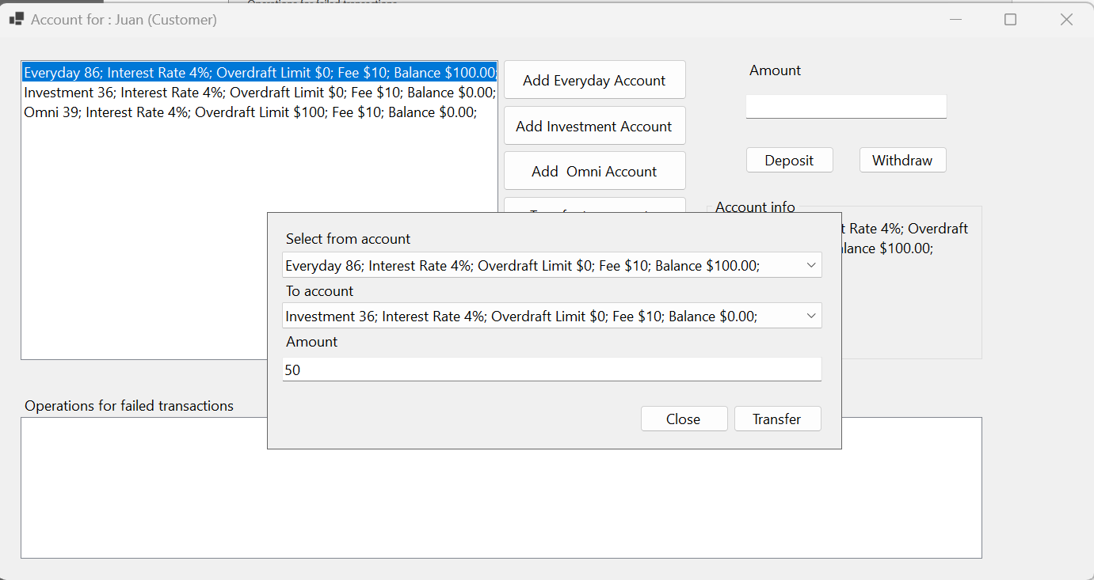

An alert wil pop-up confirming the successful transfer and the user will be able to see the ammounts updated in the box where the accounts are also showing the interest rate charged:

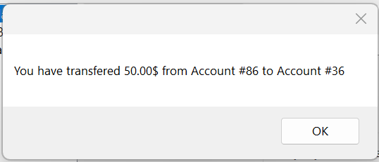

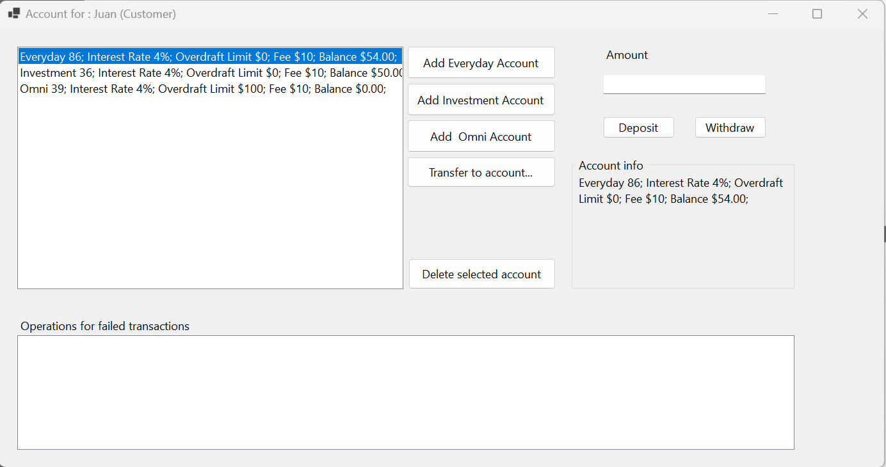

**Making a Withdrawal**

1. The user has to position on the amount the money will be withdrawn from.
2. Type the amount to be withdrawn and click on withdraw.

An alert will pop-up telling the user the amount that has been withdrawn:

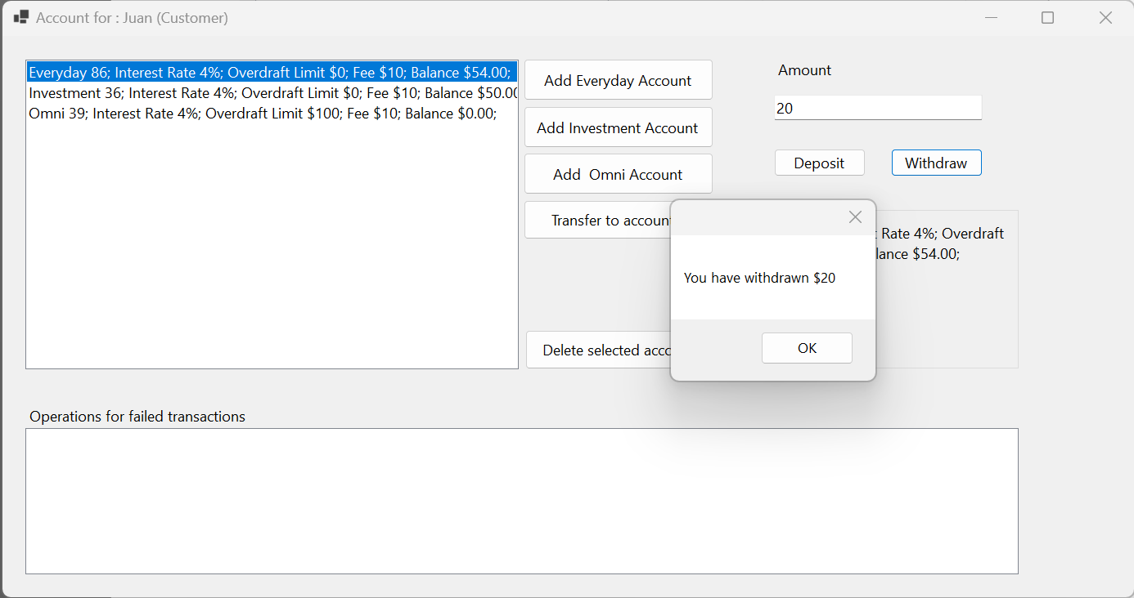

After clicking “**OK**” the accounts box will update and the current amount will be shown in the account:

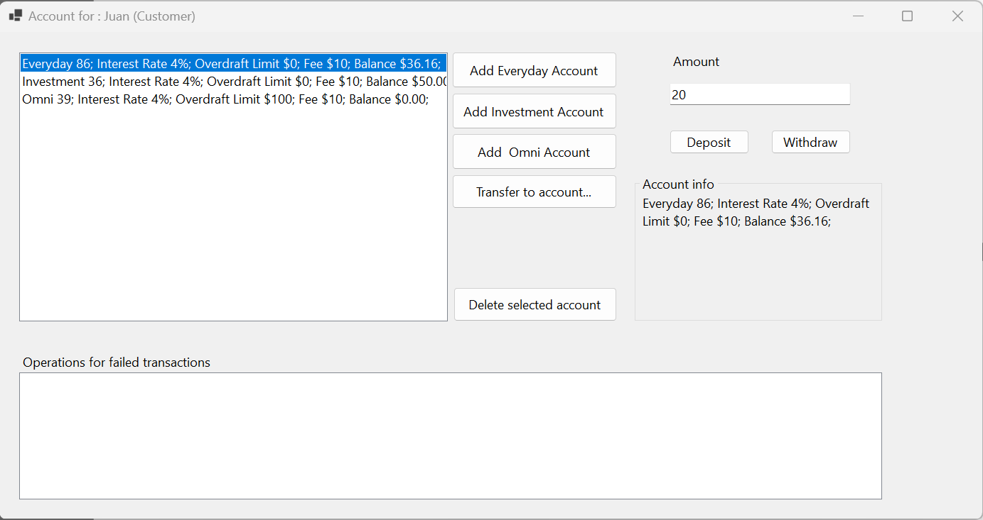

**Operations for failed transactions**

When the user tries to withdraw more money than what the account has a description will be shown in the **“Operation for failed transactions”** box at the bottom of the form.

